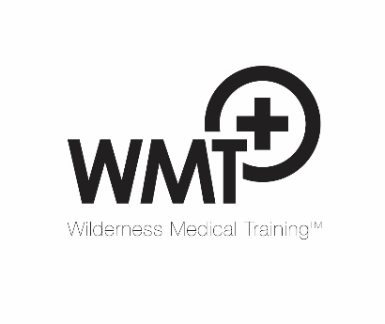
WMT Programme Participation Declaration – UK courses (v1.0)

To discharge its duty of care to students and fulfil insurance requirements, WMT requires delegates to complete this declaration. Please PRINT THIS FORM and submit it to WMT in confidence on arrival.

- I confirm I am in good health and will not participate under the influence of alcohol, or drugs that will affect my safety or that of others.
- I accept that all the outdoor activities on the programme involve risk and this cannot be completely eliminated even under the supervision of professional instructors.
- I agree to abide by the safety instructions issued by all instructors.
- I have disclosed below any medical history and condition(s) that might compromise my health or safety or that of others that the organisers should be aware of when in an outdoor setting.
- I give the organisers permission to administer medical aid to me should I be unable to give my consent.
- Swimming ability – circle one option: I cannot swim I am a competent swimmer
- I agree to conform to Covid-19 mitigation measures that may be imposed on the course
- I confirm that I do not have Covid-19 symptoms and have not been diagnosed with Covid-19 within 14 days of the course start date.
- If I experience Covid-19 symptoms during the course, I agree to tell the organisers and take a lateral flow test. If positive, I accept I will be asked to leave the course.

My emergency contact is: (name) Contact number(s):

Medical history: please detail any significant past medical history including but not limited to serious injuries, illnesses and current medications (continue on reverse side if necessary):

Name: Date:

